Resumos IES - AT1

1. Introduction to Software Engineering 2
1.1 - Importance of Software Engineering 2
1.2 - SE Methodology 2
1.3 - SUMMARY 3
2. The Software Development Process 4
2.1 - SW Process 4
2.2 - Plan-driven and agile processes 5
2.3 - SW Process Models 5
2.4 - Waterfall Model 5
2.5 - Incremental Model 6
2.6 - Evolutionary models 7
2.7 - Other process models 7
2.8 - SUMMARY 8
3. Agile Software Development 9
3.1 - Agile Methods 9
3.1.1 - The principles of agile methods 9
3.1.2 - Plan-driven and agile development 10
3.2 - Agile Development Techniques 11
3.2.1 - Extreme Programming (XP) 11
3.2.2 - User Stories for Specification 13
3.2.3 - Refactoring 13
3.2.4 - Test-First Development 14
3.2.5 - Pair Programming 15
3.3 - Agile Project Management 15
3.4 - Scaling Agile Methods 18
3.5 - SUMMARY 20
4. DevOps 21
4.1 - DevOps 21
4.2 - Continuous Integration (CI) 23
4.3 - Continuous Delivery (CD) 24
4.4 - SUMMARY 27
5. Enterprise architecture patterns 28
5.1 - Simple Architecture Patterns 28
5.2 - Architecture Patterns 28
5.2.1 - MicroKernel Architecture 28
5.2.2 - Layered Architecture 29
5.2.3 - Event-Driven Architecture 29
5.2.4 - Service-oriented Architecture (SOA) 29
5.2.5 - Microservices Architecture 32
5.2.6 - Space-Based Architecture 33
5.3 - SUMMARY 33
6. Backend Web Framework 34
6.1 - Web Applications 34
6.1.2 - Static and Dynamic 34
6.2 - Backend development 34
6.2.1 - Frameworks 35
6.2.2 - N-Tier 37
6.2.3 - MVC 37
7. Spring Framework 39
7.1 - Architecture 39
7.2 - Annotations 39
7.3 - Inversion of Control (IoC) 40
7.4 - Dependency Injection (DI) 40
7.5 - Spring IoC Container 41
7.6 - Beans 42
7.7 - Aspect Oriented Programming (AOP) 45
7.8 - Spring Web 46
7.9 - Spring Data Access modules 47

1. Introduction to Software Engineering
Software engineering is the technology that encompasses a process, a set of methods and an array of tools.

1.1 - Importance of Software Engineering
- Reduces complexity
- Minimizes risks, software cost and delivery time
- Allow managing large projects
- Enforces development of reliable software
- Standardize processes

1.2 - SE Methodology
- SE focuses mostly on processes for achieving goals
  - Process must be systematic
  - Design of proper processes and their control is a key challenge SE faces
- SE separates process for developing sw from the developed product (i.e the sw)
  - SW process is the equivalent of manufacturing process
- The development process is typically phased
  - Phases separate concerns with each phase focusing on some aspect
    - Requirements, architecture, design, coding, testing are key phases
  - This phased process has to be properly managed to achieve the objectives
    - Metrics and measurement important for this

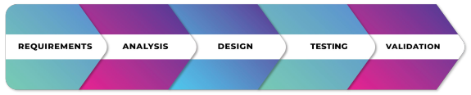
Software Architect role: Makes high-level design choices and dictates technical standards, including software coding standards, tools, and platforms.

SE Phases

Work with your team, discuss ideas, be open minded, propose your ideas, etc.

Key issues: Methods, Time Management, Efficiency, Quality, Ethics.

1.3 - SUMMARY
- The problem domain for software engineering is industrial strength software

- Software comprises programs, documentation, and data

- Software engineering aims to provide methods for systematically developing high quality products with the high productivity and low costs

2. The Software Development Process
Process: Foundation for software engineering
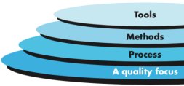
SW Process: framework for the activities, actions, and tasks that are required to build high-quality software. It establishes the technical and management framework for applying methods, tools, and people to the development task.

A process makes SW development more orderly and manageable

2.1 - SW Process
SW Process involve:
- Specification (communication and planning): defining what the system should do;
- Design and implementation: defining the organization of the system and implementing the system;
- Validation: checking that it does what the customer wants;
- Evolution: changing the system in response to changing customer needs.

Quando descrevemos e discutimos processos falamos de:
- the activities in these processes such as specifying a data model, designing a user interface, etc. and
- the ordering of these activities.

Process description podem também incluir:
- Products, which are the outcomes of a process activity;
- Roles, which reflect the responsibilities of the people involved in the process;
- Pre- and post-conditions, which are statements that are true before and after a process activity has been enacted or a product produced.

SW Process specifies: What, who, when
SW Process includes: Roles, Workflows, Templates, etc

SW Process is a guide. The process that someone selects depends on:
- the specific characteristics of the project
- the organization’s culture
- the abilities and preferences of the people involved
A good process will raise the productivity of less experienced team members without impeding the work/progress of more experienced team members.

2.2 - Plan-driven and agile processes
Plan-driven processes: processes where all of the process activities are planned in advance and progress is measured against this plan.
Agile processes: planning is incremental and it is easier to change the process to reflect changing customer requirements.
Na prática, os processos incluem elementos de ambos.

2.3 - SW Process Models
Abstract models that describe a class of development approaches with similar characteristics.
Criteria to distinguish SW Process:
- timing between phases,
- entry and exit criteria between phases
- the artifacts created during each phase.

Traditional SW Process Models:
- The waterfall model: Plan-driven model. Separate and distinct phases of specification and development.
- Incremental development: Specification, development and validation are interleaved. May be plan-driven or agile.
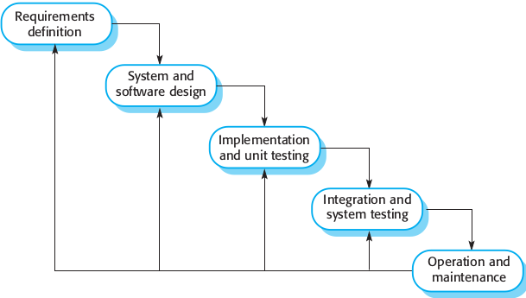
- Evolutionary processes: The system is developed from start with very raw specification and modifying this according to the software needs.

2.4 - Waterfall Model

Advantages:
- Simple and easy to understand and use.
- Easy to plan
  - A schedule can be set with deadlines for each stage of development and a product can proceed through the development process like a car in a car-wash, and theoretically, be delivered on time.
- Easy to manage: each phase has specific deliverables and a review process.
- Phases are processed and completed one at a time.
- Works well where requirements are very well understood.

Disadvantages
- Difficulty of accommodating change after the process is underway.
  - In principle, a phase has to be complete before moving onto the next phase.
  - Inflexible partitioning of the project into distinct stages makes it difficult to respond to changing customer requirements.
- Poor model for long and ongoing projects.
  - No working software is produced until late during the life cycle.
- Not suitable for the projects where requirements are uncertain or at the risk of changing.
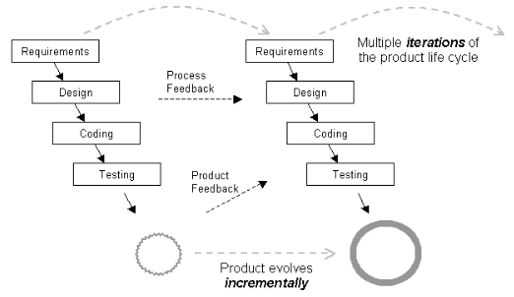

2.5 - Incremental Model
A characteristic of modern life cycle models. The product evolves incrementally over a series of iterations.

Benefits:
- The cost of accommodating changing customer requirements is reduced.
  - The amount of analysis and documentation that has to be redone is much less than is required with the waterfall model.
- It is easier to get customer feedback on the development work that has been done.
  - Customers can comment on demonstrations of the software and see how much has been implemented.
- More rapid delivery and deployment of useful software to the customer is possible.
  - Customers are able to use and gain value from the software earlier than is possible with a waterfall process.

Problems:
- Each iteration phase is rigid and does not overlap each other.
- The process is not visible.
  - Managers need regular deliverables to measure progress. But, if systems are developed quickly, it is not cost-effective to produce documents that reflect every version of the system.
- System structure tends to degrade as new increments are added.
  - Unless time and money is spent on refactoring to improve the software, regular change tends to corrupt its structure.
  - Incorporating further software changes becomes increasingly difficult and costly.

2.6 - Evolutionary models
- Prototyping
  - Often, a customer defines a set of general objectives for software, but does not identify detailed requirements for functions and features.
- Spiral Model
  - Using the spiral model, software is developed in a series of evolutionary releases. During early iterations, the release might be a model or prototype.
- Concurrent Model
  - allows a software team to represent iterative and concurrent elements of any of the process models.

2.7 - Other process models
- Component-based development (COTS)
  - the process to apply when reuse is a development objective
- Formal methods
  - emphasizes the mathematical specification of requirements
- Aspect-oriented software development (AOSD)
  - provides a process and methodological approach for defining, specifying, designing, and constructing aspects
- Unified Process
  - a “use-case driven, architecture-centric, iterative and incremental” software process closely aligned with the Unified Modeling Language (UML)

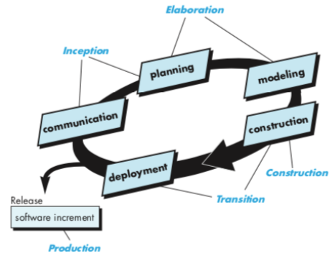
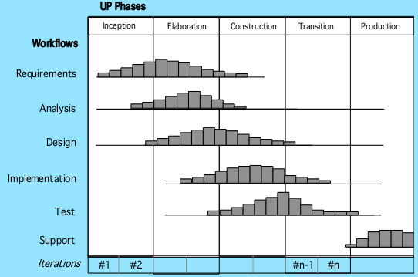

2.8 - SUMMARY
- The software process
- Sequential model
  - Waterfall, V-Models
- Incremental model
- Evolutionary models
  - Prototyping, Spiral
- Specialized models
  - COTS, Formal methods
  - Unified Process

3. Agile Software Development

3.1 - Agile Methods
Why agile?
- Rapid development and delivery is now often the most important requirement for software systems
  - Businesses operate in a fast–changing requirement and it is practically impossible to produce a set of stable software requirements
  - Software has to evolve quickly to reflect changing business needs.
- Plan-driven development is essential for some types of system but does not meet these business needs.

Agile methods were developed in an effort to overcome perceived and actual weaknesses in conventional software engineering.

These methods:
- Focus on the code rather than the design
- Are based on an iterative approach to software development
- Are intended to deliver working software quickly and evolve this quickly to meet changing requirements.

- Individuals and interactions over processes and tools
- Working software over comprehensive documentation
- Customer collaboration over contract negotiation
- Responding to change over following a plan

3.1.1 - The principles of agile methods
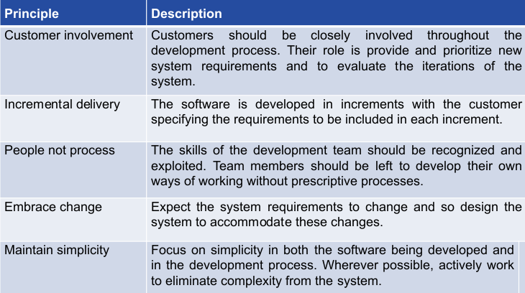

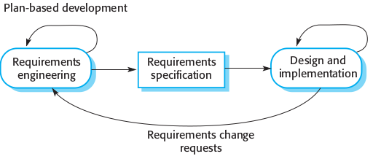
3.1.2 - Plan-driven and agile development
- Plan-driven development
  - A plan-driven approach to software engineering is based around separate development stages with the outputs to be produced at each of these stages planned in advance.
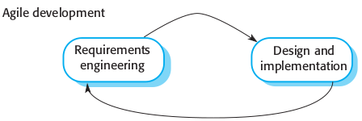
  - Not necessarily waterfall model – plan-driven, incremental development is possible
- Agile development
  - Specification, design, implementation and testing are interleaved
  - The outputs from the development process are decided through a process of negotiation during the software development process.

Agile benefits:
- Requirements in Agile model can change as per the customer requirement.
  - Sometimes requirements are not very clear.
  - Changes in the requirements are accepted even in the later stages of the development.
- The delivery of software is continuous.
  - The customers can follow every Sprint working feature of the software.
- Refactoring is not costly.

Agile Disadvantages:
- The documentation is sparse.
- With unclear requirement it is difficult to predict the expected result.
  - More difficult to estimate the effort required.
- Some unknown/unpredicted risks which can affect the development of the project.

Agile Applicability:
- Product development
  - where a software company is developing a small or medium-sized product for sale.
- Custom system development within an organization
  - where there is a clear commitment from the customer to become involved in the development process, and
  - where there are few external rules and regulations that affect the software.
- Virtually all software products and apps are now developed using an agile approach

3.2 - Agile Development Techniques
- Program specification, design and implementation are interleaved
- The system is developed as a series of versions or increments with stakeholders involved in version specification and evaluation
- Frequent delivery of new versions for evaluation
- Extensive tool support (e.g. automated testing tools) used to support development
- Minimal documentation
  - focus on working code

3.2.1 - Extreme Programming (XP)
Extreme Programming (XP) is the most widely used approach to agile software development.
- It takes an ‘extreme’ approach to iterative development.
  - New versions may be built several times per day;
  - Increments are delivered to customers every 2 weeks;
  - All tests must be run for every build and the build is only accepted if tests run successfully.
- Uses an object-oriented approach as its preferred development paradigm.
- Encompasses a set of rules and practices that occur within the context of four framework activities: planning, design, coding, and testing.
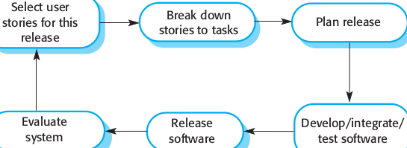

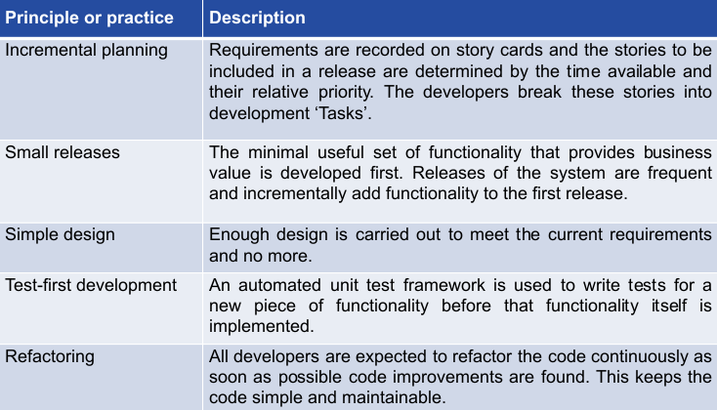

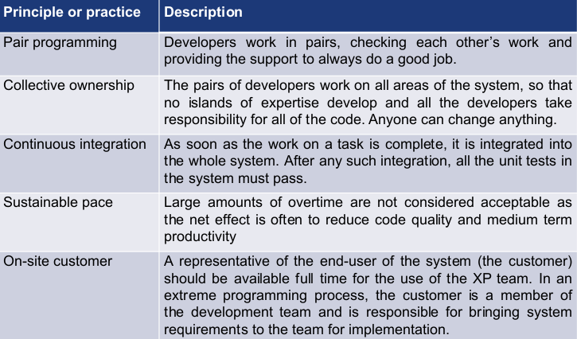

Extreme programming has a technical focus and is not easy to integrate with management practice in most organizations.
- Consequently, while agile development uses practices from XP, the method as originally defined is not widely used.

3.2.2 - User Stories for Specification
- In XP, a customer or user is part of the XP team and is responsible for making decisions on requirements.
- User requirements are expressed as user stories or scenarios.
- These are written on cards and the development team break them down into implementation tasks.
  - These tasks are the basis of schedule and cost estimates.
- The customer chooses the stories for inclusion in the next release based on their priorities and the schedule estimates.

User Stories Organization:
- Role-Goal-Benefit: It forces the customer to really think about who is going to benefit from a feature, what they're trying to achieve, and why they want to achieve that.
- Limitations, needs: Subset of situations that matter for this feature.
- Definition of Done: How to validate the feature and know that it is complete
- Engineering tasks: How this feature interacts with other features within the system or other subsystems.
- Effort estimate: It provides a concrete measurement about the value of a
- feature.

3.2.3 - Refactoring
Conventional wisdom in software engineering is to design for change.
- It is worth spending time and effort anticipating changes as this reduces costs later in the life cycle.
XP, however, maintains that this is not worthwhile as changes cannot be reliably anticipated.
- Rather, it proposes constant code improvement (refactoring) to make changes easier when they have to be implemented.

- This improves the understandability of the software and so reduces the need for documentation.
- Changes are easier to make because the code is well-structured and clear.
- However, some changes requires architecture refactoring and this is much more expensive.

Examples of refactoring: remove duplicate code, make code easier to understand, implement new methods

3.2.4 - Test-First Development
Testing is central to XP and XP has developed an approach where the program is tested after every change has been made.
XP testing features:
- Test-first development.
- Incremental test development from scenarios.
- User involvement in test development and validation.
- Run all component tests each time that a new release is built.

Test Automation:
- Tests are written as executable components before the task is implemented. They should
  - be stand-alone,
  - simulate the submission of input to be tested,
  - check that the result meets the output specification.
- An automated test framework (e.g. Junit) makes it easy to write and execute tests.
- As testing is automated, there is always a set of tests that can be quickly and easily executed.
  - Whenever any functionality is added to the system, the tests can be run and problems that the new code has introduced can be caught immediately.

Problems with test-first developmment:
- Programmers prefer programming to testing and sometimes they take short cuts when writing tests.
  - For example, they may write incomplete tests that do not check for all possible exceptions that may occur.
- Some tests can be very difficult to write incrementally.
  - For example, in a complex user interface, it is often difficult to write unit tests for the code that implements the ‘display logic’ and workflow between screens.
- It is difficult to judge the completeness of a set of tests.
  - Although you may have a lot of system tests, your test set may not provide complete coverage.

3.2.5 - Pair Programming
- Pair programming involves programmers working in pairs, developing code together.
- This helps developing common ownership of code and spreads knowledge across the team.
- It serves as an informal review process as each line of code is looked at by more than 1 person.
- It encourages refactoring as the whole team can benefit from improving the system code.

- In pair programming, programmers sit together at the same computer to develop the software.
- Pairs are created dynamically so that all team members work with each other during the development process.
- The sharing of knowledge that happens during pair programming is very important as it reduces the overall risks to a project when team members leave.
- Pair programming is not necessarily inefficient
  - There is some studies that suggests that a pair working together is more efficient than 2 programmers working separately.

3.3 - Agile Project Management
The principal responsibility of software project managers is to manage the project
- so that the software is delivered on time and within the planned budget for the project.
The standard approach to project management is plan-driven.
- Managers draw up a plan for the project showing what should be delivered, when it should be delivered and who will work on the development of the project deliverables.
Agile project management requires a different approach,
- which is adapted to incremental development and the practices used in agile methods.

SCRUM
Scrum: agile method that focuses on managing iterative development rather than specific agile practices
Scrum Phases:
- 1. The initial phase is an outline planning phase where you establish the general objectives for the project and design the software architecture.
- 2. This is followed by a series of sprint cycles, where each cycle develops an increment of the system.
- 3. The project closure phase wraps up the project, completes required documentation such as system help frames and user manuals and assesses the lessons learned from the project.

Scrum Terminology:
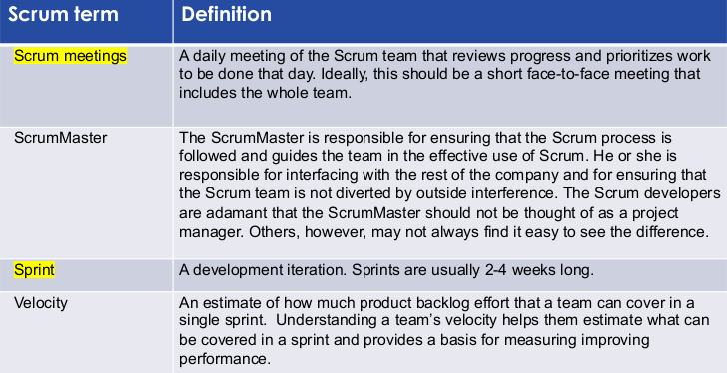

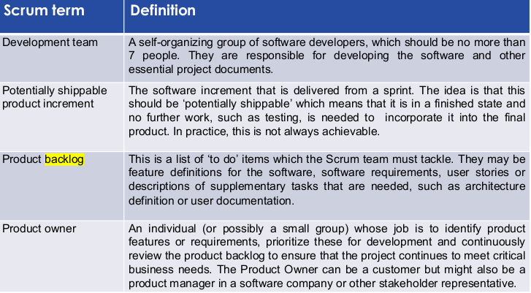
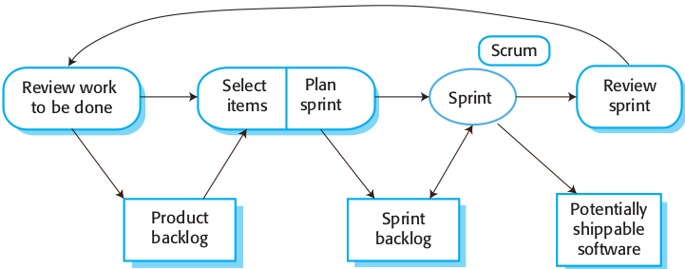
Scrum Sprint Cycle
Starting point: product backlog - list of work to be done on the project.
Selection Phase: involves all the team
Development stage: team is isolated
from the customer and the organization
End of the sprint: work done is reviewed and presented to stakeholders

TeamWork in SCRUM
Scrum Master: protect the development team from external distractions - arranges daily meetings, records decisions, etc
- The team attends short daily meetings (Scrums)

Scrum Benefits:
- The product is broken down into a set of manageable and understandable chunks.
- Unstable requirements do not hold up progress.
- The whole team have visibility of everything and consequently team communication is improved.
- Customers see on-time delivery of increments and gain feedback on how the product works.
- Trust between customers and developers is established and a positive culture is created in which everyone expects the project to succeed.

Kanban
Lean agile system that can be used to enhance any software development lifecycle including Scrum, XP, or Waterfall.

Scrum vs Kanban
Kanban has less rules than Scrum
In Scrum, you select the work you'll be doing for the next sprint beforehand.
- You then lock the sprint, do all the work, and after a couple of weeks - the usual sprint duration - your queue is empty.
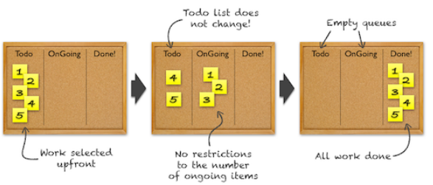

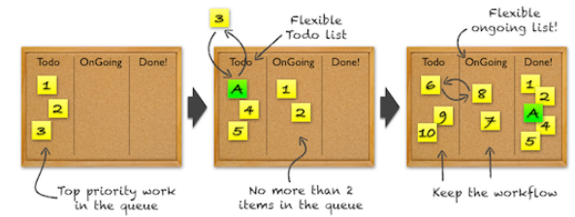
In Kanban, all that's limited is the size of the queues, called the Work In Progress limit.
- We can change the items in the queues at any time, and that there's no "sprint end". The work just keeps flowing.
- Kanban flow, with a WIP limit of 3 for the Todo, and 2 for the Ongoing

Why limit the WIP?
Limiting WIP may have the following effects:
- Reduces cycle time per task
- Insures WIP is highest priority task
- Reduces or eliminates queues between groups
- Reduces multi-tasking by team members
- Reduces lead times and increases quality
Good limit factor: Number of people x 1.5

3.4 - Scaling Agile Methods
When scaling agile methods it is important to maintain agile fundamentals:
- Flexible planning, frequent system releases, continuous integration, test-driven development and good team communications.

System Issues:
How large is the system being developed?
- Agile methods are most effective a relatively small co-located team who can communicate informally.
What type of system is being developed?
- Systems that require a lot of analysis before implementation need a fairly detailed design to carry out this analysis.
What is the expected system lifetime?
- Long-lifetime systems require documentation to communicate the intentions of the system developers to the support team.
Is the system subject to external regulation?
- If a system is regulated you will probably be required to produce detailed documentation as part of the system safety case.

Organizational Issues
Will customer representatives be available to provide feedback of system increments?
Can informal agile development fit into the organizational culture of detailed documentation?
How good are the designers and programmers in the development team?
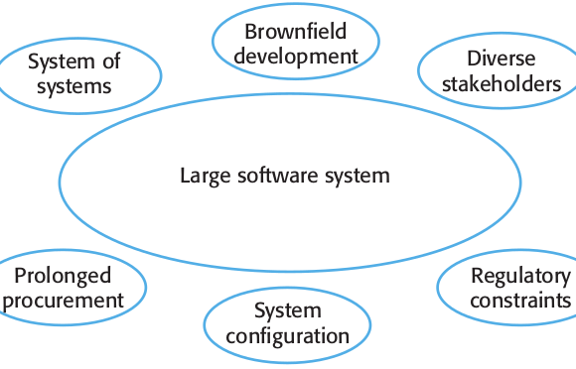

Large system Development
Large systems are usually collections of separate, communicating systems, where separate teams develop each system.
Large systems are ‘brownfield systems’, that is they include and interact with a number of existing systems.
Large systems and their development processes are often constrained by external rules and regulations limiting the way that they can be developed.
Large systems have a long procurement and development time.
- It is difficult to maintain coherent teams who know about the system over that period as, inevitably, people move on to other jobs and projects.
Large systems usually have a diverse set of stakeholders.

Agile: Scaling up to large systems
- A completely incremental approach to requirements engineering is impossible.
- There cannot be a single product owner or customer representative.
- For large systems development, it is not possible to focus only on the code of the system.
- Cross-team communication mechanisms have to be designed and used.
- Continuous integration is practically impossible. However, it is essential to maintain frequent system builds and regular releases of the system.

Multi-team SCRUM
- Role replication: Each team has a Product Owner for their work component and ScrumMaster.
- Product architects: Each team chooses a product architect and these architects collaborate to design and evolve the overall system architecture.
- Release alignment: The dates of product releases from each team are aligned so that a demonstrable and complete system is produced.
- Scrum of Scrums: There is a daily Scrum of Scrums where representatives from each team meet to discuss progress and plan work to be done.

3.5 - SUMMARY
- Agile methods are incremental development methods
- Agile development practices include
  - User stories for system specification
  - Frequent releases of the software,
  - Continuous software improvement
  - Test-first development
  - Customer participation in the development team.
- Scrum is an agile method that provides a project management framework.
  - It is centred round a set of sprints, which are fixed time periods when a system increment is developed.
- Many practical development methods are a mixture of plan-based and agile development.
- Scaling agile methods for large systems is difficult.
  - Large systems need up-front design and some documentation and organizational practice may conflict with the informality of agile approaches.

4. DevOps
Agile methodology:
- Each project is broken up into several iterations
- All iterations should be of the same time duration (2-8 weeks)
- At the end of each iteration a working product should be delivered
Limitations of agile:
- Dev part is continuous (Development)
- Ops is not continuous (Operation)

4.1 - DevOps
DevOps: is about removing the barriers between two traditionally siloed teams, development and operations.
The two teams work together to optimize both the productivity of developers and the reliability of operations.
- They strive to communicate frequently, increase efficiencies, and improve the quality of services they provide to customers.
- They take full ownership for their services, often beyond where their stated roles or titles have traditionally been scoped by thinking about the end customer’s needs and how they can contribute to solving those needs.
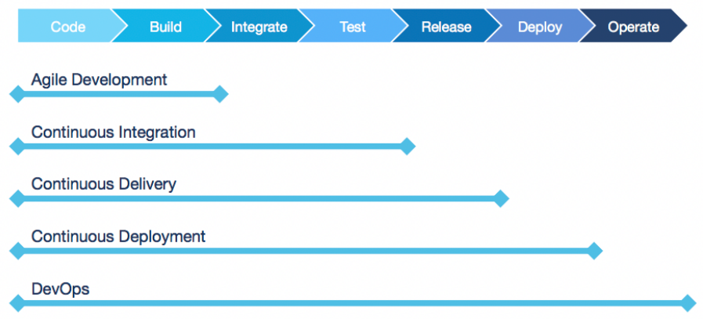
DevOps Lifecycle

DevOps Stages
Agile Development: Source Code Management (Plan, Code, Build), Maintain different versions of the code.
Continuous Integration (Integrate, Test): Compile, Validate, Code Review, Unit Testing, Integration Testing.
Continuous Delivery (Release)
- Deploying the build application
- Performing user acceptance testing (UAT).
Continuous Deployment (Deploy, Operate): Deploying the tested/accepted application.
Continuous Monitoring
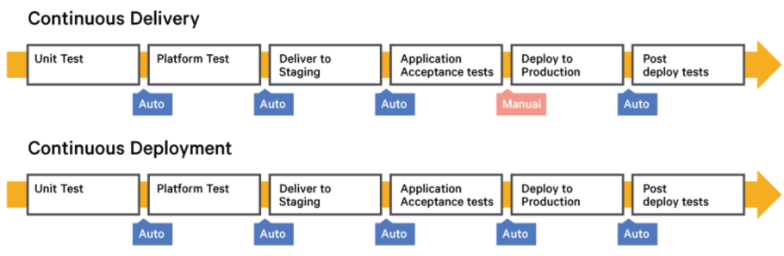
CD - Continuous Delivery/Deployment

DevOps Lifecycle
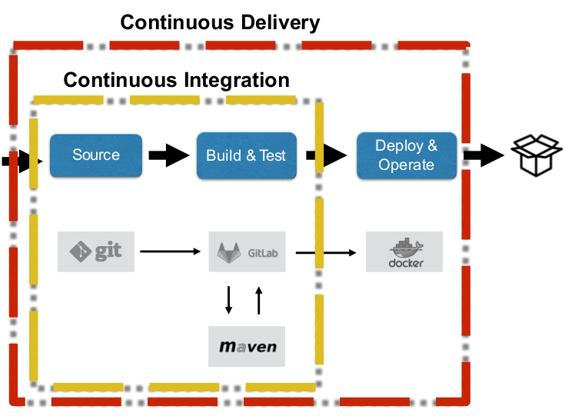

Infrastructure as a code: that is described by code can thus be tracked, validated, and reconfigured in an automated way.

Benefits of DevOps
- Speed: Move at high velocity so you can innovate for customers faster, adapt to changing markets better, and grow more efficient at driving business results.
- Reliability: Ensure the quality of application updates and infrastructure changes so you can reliably deliver at a more rapid pace while maintaining a positive experience for end users. (use CI and CD to ensure)
- Scale: Automation and consistency help you manage complex or changing systems efficiently and with reduced risk.
- Improved collaboration: Developers and operations teams collaborate closely, share many responsibilities, and combine their workflows.
- Security: Move quickly while retaining control and preserving compliance. You can adopt a DevOps model without sacrificing security by using automated compliance policies, fine-grained controls, and configuration management techniques.

4.2 - Continuous Integration (CI)
Continuous integration: a process where the code is checked into a repository very frequently.

Why is CI crucial for DevOps?
Errors Detected Early
- If it is an error in the local copy or code, a build failure will occur at the "appropriate stage".
- It forces the developer to fix the bug before proceeding further. QA teams will also be benefited from this as they will mostly be working on stable builds.
Decreases bug accumulation
- With the use of CI the piling of bugs is reduced greatly.
- Bugs are easy to find early and fix, greatly reducing risks.
Setting the stage for CI/CD
- CI reduces manual intervention because build, sanity, and other tests are all supposed to be automated.
- This paves way for a successful continuous delivery.
Project Confidence

CI needs
Version Control System (git)
CI Server
Build Script (maven)

CI Principles
Versioning
- Shared repository to maintain code: All source files (executable code, configuration, host environment, and data) are committed to a version- control repository.
- Merge Daily: Changes committed to the mainline are applied to each branch on at least a daily basis.
- Short-Lived Branches: Branches must be short lived – ideally less than a few days and never more than an iteration.
Build Configuration
- Independent build: Write build scripts that are decoupled from IDEs. These build scripts are executed by a CI system so that software is built at every change.
- Build at every change: Building and testing software with every change committed to a project’s version control repository.
- Build Threshold: Fail a build when a project rule is violated – such as architectural breaches, slow tests, and coding standard violations.
Team Policy
- Stop the line: Fix software delivery errors as soon as they occur. No one checks in on a broken build as the fix becomes the highest priority.
- Commit Often: Each team member checks in regularly to trunk - at least once a day but preferably after each task to trigger the CI system.
- Continuous Feedback: Send automated feedback from CI system to all Cross-Functional Team members.
- Fail Fast: Fail the build as soon as possible. Design scripts so that processes that commonly fail run first.
- Fast Builds: A build provides feedback on common build problems as quickly as possible - usually in under 10 minutes.

4.3 - Continuous Delivery (CD)
Based on CI
- CI focuses on development teams, the output of CI is the input to manual testing process and to the rest of the release process
- Plenty of time is “wasted” on this way through testing and operations
- Software sometimes undeployable because it takes too long to get it into production-like environments and because of a slow feedback loop between dev, QA, and operations

CD Prevents this by:
- close, collaborative working relationship between the stakeholders involved in delivery
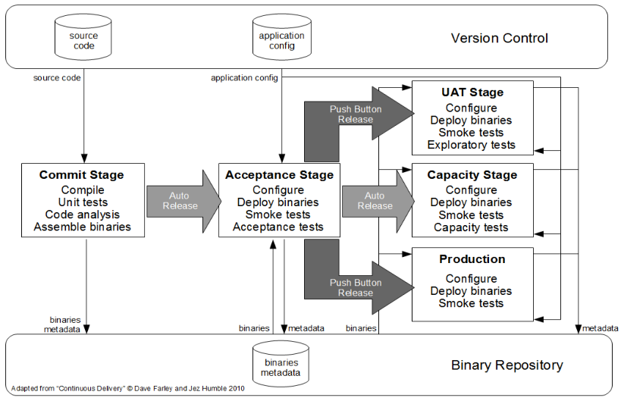
- extensive automation of all parts of the delivery process (CD pipeline)

CI Phase: Commit stage, Application config, binaries metadata

Post CI Phase: Acceptance Stage, UAT Stage, Capacity Stage
- Consist of multiple environments/stages for testing purposes
- Include manual and automated testing
- Some stages might run in parallel
- Stages are either automatically executed when previous stage is finished, or after manual approval

CD Phase: Production
- New version is available to be released to customers
- Various strategies and practices exist for rolling out:
  - Eat your own dog food
  - canary release
  - gradual rollouts
  - A/B testing
  - dark launches
  - blue/green deployments

Eat your own dog food: company uses its own product to test and promote the product

Canary releases: release a new version to a subset of users first, while all other users interact with the old, stable version
- In case of issues with new version, only a small number of users is affected, thus the impact of the issue is kept small

Gradual Rollouts: increase the number of users assigned to the newest version in a stepwise manner until it completely replaces the former version
- Shows whether the new version can cope with increasing load and scales correctly
- Sometimes used with canary releases

A/B Testing: compare two versions of software with each other, often only differentiated in one tested aspect, to determine the effect of a certain change
- form of statistical hypothesis testing, thus requires big enough sample size to have “statistical power”
- mainly used on UI for testing various layouts or design aspects

Dark Launches: mitigate performance and reliability issues of new features when facing production-like load levels by deploying those features on production without being visible for users
- Through monitoring, dev teams are able to identify and fix remaining bugs and scalability concerns before enabling the feature for users

Blue/Green Deployments: have two identical production environments, one hosting (green) the current, stable version, the other (blue) represents the final stage of testing for the new version.
- Release: simply switch the router so that all incoming traffic goes to the blue (or green) environment and use the green (or blue) environment for testing the next version.
- Advantage: in case of problems directly after the release, a quick rollback (switch) to the previous version is possible
- Obstacle: DBs are part of both environments, thus a switch requires DB migration/ synchronization

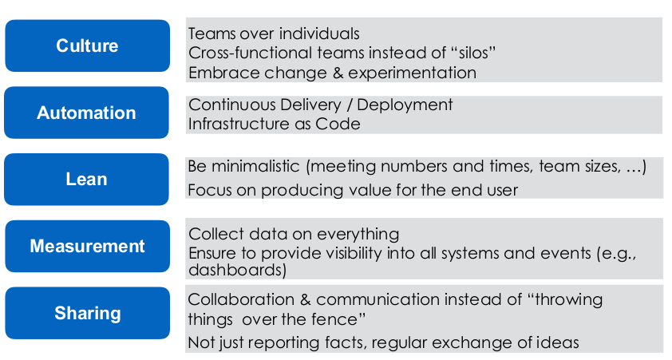
DevOps - CALMS

4.4 - SUMMARY
DevOps Technical benefits:
- Continuous software delivery
- Less complex problems to fix
- Faster resolution of problems
DevOps Business benefits:
- Faster delivery of features (time to market)
- More stable operating environments
- More time available to add value (rather than fix/maintain)

5. Enterprise architecture patterns
Architecture is the highest level concept of the expert developers.
Very hard to change architecture
Groundhog day anti-pattern: no one understands why a decision was made so it keeps getting discussed over and over and over...

Documenting and communicating decisions
Establish early on where your decisions will be documented and make sure every team member knows where to go to find them
- Avoid witches brew architecture: Architectures designed by groups resulting in a complex mixture of ideas and no clear vision

The goal: Using collective knowledge and experience to arrive at a unified vision for the architecture

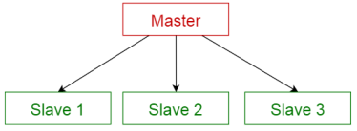
5.1 - Simple Architecture Patterns
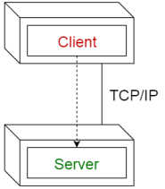
Client-Server Pattern

Master-Slave Pattern
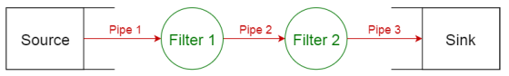
Pipe-filter pattern

5.2 - Architecture Patterns

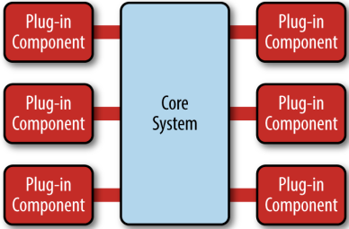
5.2.1 - MicroKernel Architecture
Core application (stable) + plugins (dynamic)
- New application features are added as plug-ins
- Extensibility, feature separation and isolation.
Can be embedded or used as part of another architecture pattern
- good first choice for product-based applications.

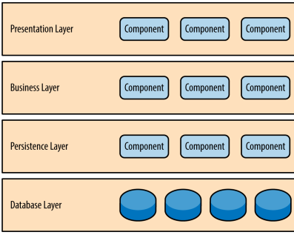
5.2.2 - Layered Architecture
Each layer has a specific role and responsibility.
- Separation of concerns
Closely matches the organizational structures found in most companies.
Solid general-purpose pattern
- making it a good starting point for most applications
- Most common n-tier architecture pattern.
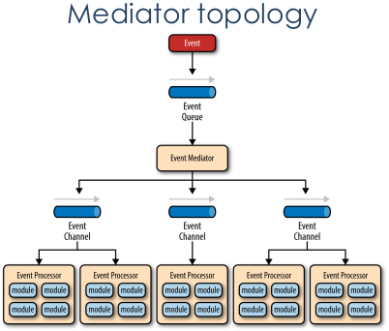

5.2.3 - Event-Driven Architecture
Distributed and asynchronous
- used to produce highly scalable applications.
- AKA, message-driven or stream processing
The event-driven architecture pattern is a relatively complex pattern to implement, primarily due to its asynchronous distributed nature.
Lack of atomic transactions for a single business process.
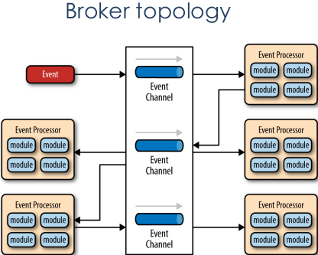
- Event processor components are highly decoupled and distributed,
- it is very difficult to maintain a transactional unit of work across them.
A key aspect is the creation, maintenance, and governance of the event-processor component contracts.

5.2.4 - Service-oriented Architecture (SOA)
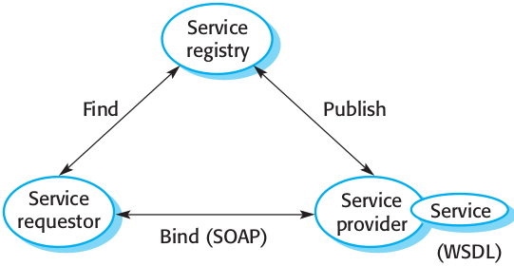
A means of developing distributed systems where the components are stand-alone services
Key Characteristics: Loose Coupling, Abstraction, Autonomy, Discoverability, etc
SOAP: A message exchange standard that supports service communication
WSDL (Web Service Definition Language): This standard allows a service interface and its bindings to be defined
WS-BPEL: A standard for workflow languages used to define service composition

SOAP (Simple Object Access Protocol)
Protocol based on XML language: Platform and language independent communication
Structure of SOAP Messages:
- An Envelope element that identifies the XML document as a SOAP message
- A Header element that contains header attributes
- A Body element that contains call and response information
- A Fault element containing errors and status information

RESTful Web Services
REST (REpresentational State Transfer) is an architectural style based on transferring representations of resources from a server to a client.
This style underlies the web as a whole and is simpler than SOAP/WSDL for implementing web services.
RESTful services involve a lower overhead than so-called ‘big web services’ and are used by many organizations implementing service-based systems.

REST (REpresentational State Transfer)
When REST is used, requests can be sent to various endpoints through GET, PUT, POST and DELETE HTTP requests. - Provides a stateless, simpler and lightweight way of communicating with a system.
- It uses JSON to send and receive

Resources
The fundamental element in a RESTful architecture is a resource.
Resource is simply a data element such as a catalog, a medical record, or a document, such as this book chapter.

Resources Operations
- Create – bring the resource into existence.
- Read – return a representation of the resource.
- Update – change the value of the resource.
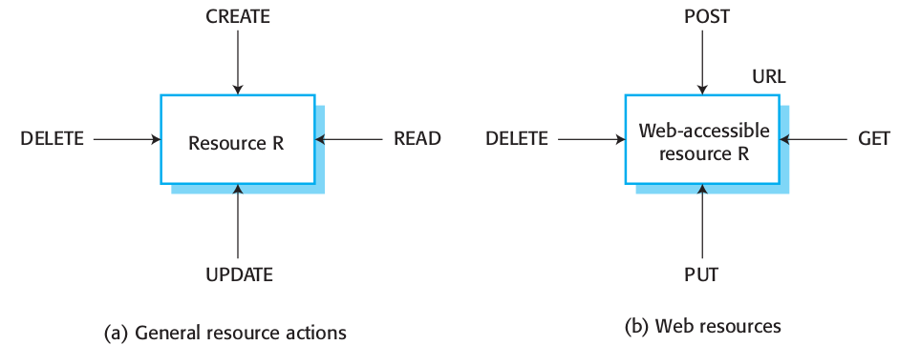
- Delete – make the resource inaccessible.

RESTful Disadvantages
- When a service has a complex interface and is not a simple resource, it can be difficult to design a set of RESTful services to represent this.
- There are no standards for RESTful interface description so service users must rely on informal documentation to understand the interface.
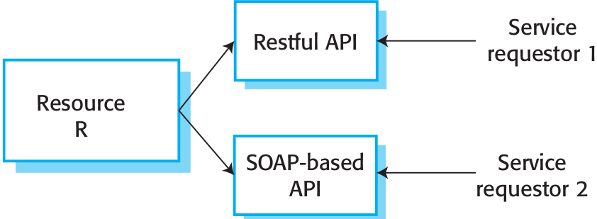
- When you use RESTful services, you have to implement your own infrastructure for monitoring and managing the quality of service and the service reliability.

RESTful and SOAP-based APIs

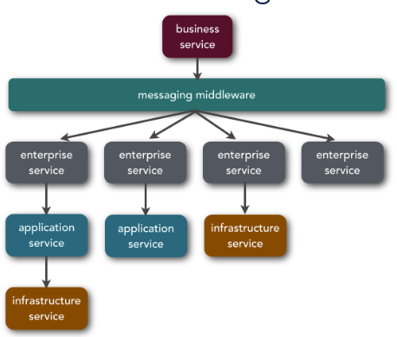
SOA topology
SOA was primarily used to develop Monolithic application, though it has evolved from there
Many use SOA to resolve integration complexities.
- Organizations in this case heavily depend on Enterprise Service Bus (ESB) technologies (messaging middleware).
- All services are accessed through the ESB.
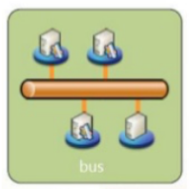
Key Characteristics of ESB
- Streamlines development
- Supports multiple binding strategies
- Performs data transformation
- Intelligent routing
- Real time monitoring
- Exception handling
- Service security

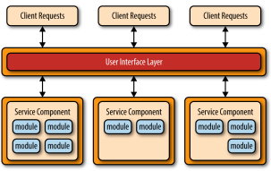
5.2.5 - Microservices Architecture
Two main sources:
- applications developed using the layered pattern
- distributed applications developed using service-oriented architecture.
The first characteristic is the notion of separately deployed units.
- Each service component is deployed as a separate unit, allowing for easier deployment and decoupling.
Distributed architecture: all the components are fully decoupled
Applications are generally more robust, provide better scalability, and can more easily support continuous delivery.
Capability to do real-time production deployments.
Only the service components that change need to be deployed.
- Distributed architecture: Iit shares some of the same complex issues found in the event-driven architecture pattern, including contract creation, maintenance, and government, remote system availability, and remote access authentication and authorization.

SOA vs Microservices
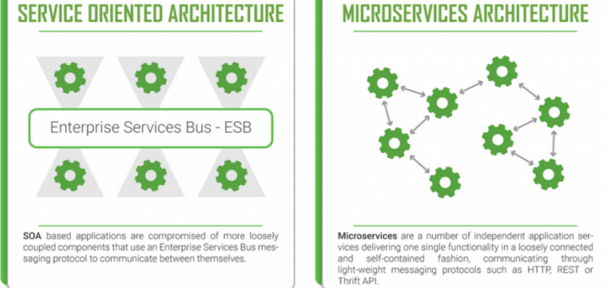

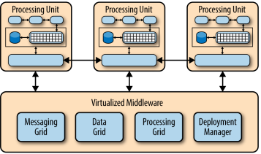

5.2.6 - Space-Based Architecture
Web-based applications
- Bottlenecks start appearing as the user load increases
- first at the web-server layer, then at the application-server layer, and finally at the database-server layer.
Specifically designed to address scalability and concurrency issues
- It is often a better approach than trying to scale out a database into a non-scalable architecture.
- A good choice for applications with variable load (social media)

5.3 - SUMMARY
A software architecture is a description of how a software system is organized.
- Properties of a system such as performance, security, and availability are influenced by the architecture used.
Architectural design decisions include decisions on:
- the type of application, the distribution of the system.
Architectures may be documented from several different perspectives.
- Possible views include a conceptual view, a logical view, a process view, a development view, and a physical view.
Architectural patterns are a means of reusing knowledge about generic system architectures.
- They describe the architecture, explain when it may be used, and point out its advantages and disadvantages.

6. Backend Web Framework

6.1 - Web Applications

6.1.2 - Static and Dynamic
Static Sites: Returns the same hard-coded content from the server whenever a particular resource is requested.
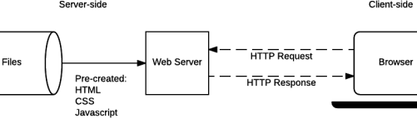
Dynamic Sites: The response content can be generated dynamically, only when needed.
A dynamic site can return different data for a URL
The code to support a dynamic website is known as back-end
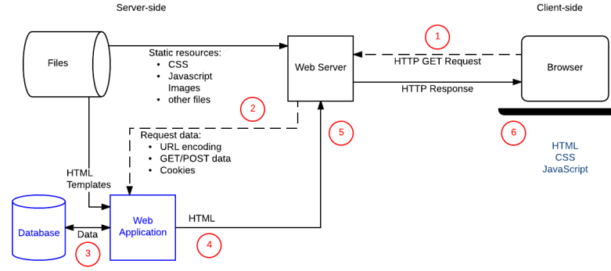

6.2 - Backend development
We need backend:
- Dynamic content: Adapt typical server-side applications to Web browsers
- Performance:
  - Avoid duplicating computation (do it once and cache)
  - Do heavy computation on more powerful machines
  - Do data-intensive computation “nearer” to the data
- Security: Validation, security, etc. that we don’t want to allow users to bypass

6.2.1 - Frameworks
(Structure): A framework is a reusable design of all or part of a system that is represented by a set of abstract classes and the way their instances interact.
(Purpose): A framework is the skeleton of an application that can be customised by an application developer.
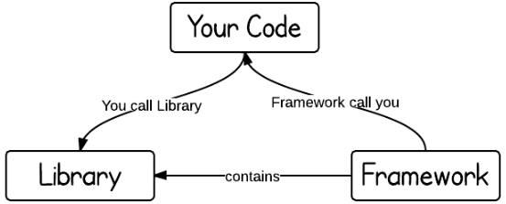
Software Frameworks
A framework provide a generic software foundation over which custom application-specific code can be written.
Frameworks differ from other class libraries by reusing high-level design:
- Libraries are used by the application-specific code to support specific features.
- Frameworks control the application flow and call application-specific code.

Libraries: call the functions in the API to do things for you
Frameworks: don’t call us, we’ll call you. Inversion of Control containers

Frameworks are normally domain-specific.
Frameworks are a form of design reuse.
Design reuse has advantages over code reuse:
- can be applied in more contexts
- applied earlier in the development process, and so can have a larger impact.

Advantages | Disadvantages
Powerful and complex | Difficult to learn
Implementation speed | Lower performance
Tested, proven solutions | Reduced independence
Access to expertise and off-the-shelf solutions | Dependence on external entities
Maintenance (i.e. updates, patches) | Technological lock-in

Client-side APIs
- Manipulate documents loaded into the browser
- Fetch data to update small sections of a webpage
- Drawing and manipulating graphics
- Client-side storage

Server-side Framework (Backend)
3 types of frameworks:
- Micro Frameworks — focused on routing HTTP request to a callback, commonly used to implement HTTP APIs. (Flask (Python))
- Full-Stack Frameworks — feature-full frameworks that includes routing, templating, data access and mapping, plus many more packages. (Django)
- Component Frameworks — collections of specialized and single-purpose libraries that can be used together to make a micro- of full-stack framework. (Angular (google), React (facebook))

Framework Components
Core Components:
- Request Routing — Match incoming HTTP requests to code
- Template Engine — Structure and separate presentation from logic
- Data Access — Uniform data access, mapping and configuration
Common Components:
- Security — Protection against common web security attacks
- Sessions — Session management and configuration
- Error Handling — Capture and manage application-level errors
- Scaffolding — Quickly generate CRUD interfaces based on data model

Request Routing: maps HTTP access requests to specific functions
- URL design is handled independently from application code using request routing

Data Independence
Logical Independence: The ability to change the logical schema without changing the external schema or application programs
– Can add new fields, new tables without changing views
– Can change structure of tables without changing view
Physical Independence: The ability to change the physical schema without changing the logical schema
– Storage space can change
– Type of some data can change for reasons of optimization
SOLUTION: Keep the VIEW (what the user sees ) independent of the MODEL (domain knowledge)

6.2.2 - N-Tier
Components: Presentation, Business, Data
N-tier architectures try to separate the components into different tiers/layers:
- Tier: physical separation
- Layer: logical separation

3-Tier Architecture
Presentation, logic and data layer are disconnected
Each layer can potentially run on a different machine
Design Problem:
- change the look-and-feel: without changing the core/logic
- present data under different contexts:
- interact with/access data under different contexts
- maintain multiple views of the same data

6.2.3 - MVC
- Separates core functionality from the presentation and control logic that uses this functionality
- Allow multiple views to share the same data model
- Make supporting multiple clients easier to implement, test, and maintain
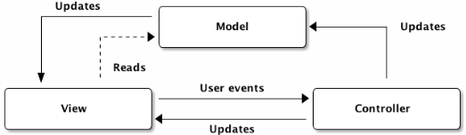
Model: The program representation of the object/database
EX: users,products, cars
View: The visual representation of your data. This is what the web app user sees
EX: HTML, CSS, JavaScript
Controller: The go-between Model and View
- One way: takes input from the View and gives it to the Model to act upon.
- Other way: Gathers data from Model(s) and gives it to the View to incorporate in the visual representation.

Spring MVC Architecture
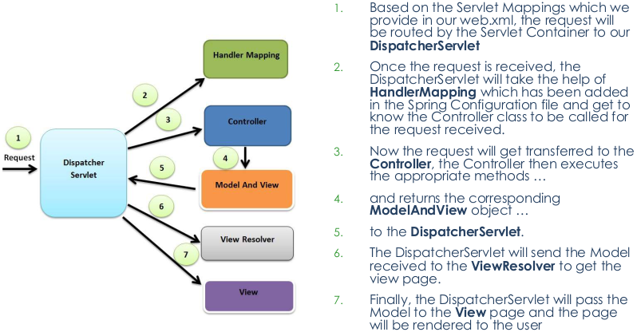
3-Tier vs MVC
Communication:
- 3-tier: The presentation layer never communicates directly with the data layer-only through the logic layer (linear topology)
- MVC: All layers communicate directly (triangle topology
Usage:
- 3-tier: Mainly used in web applications where the client, middleware and data tiers ran on physically separate platforms
- MVC: Historically used on applications that run on a single workstation

Template Engine
Template engines take in tokenized strings and produce rendered strings with values in place of the tokens as output.
- Templates are typically used as an intermediate format written by developers to programmatically produce one or more desired output formats, commonly HTML, XML or PDF.

7. Spring Framework
- A framework is something that provides a standard way to do certain things
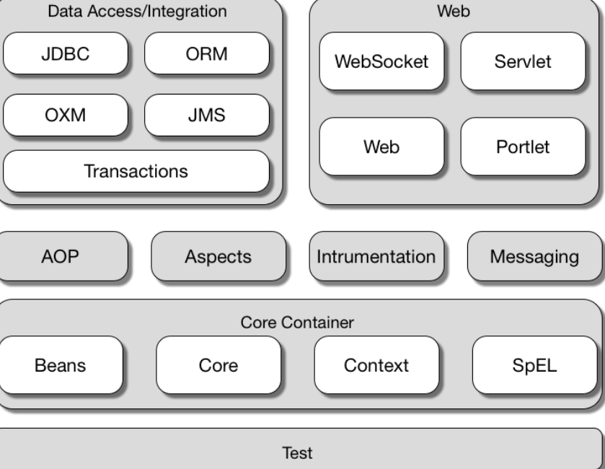
- If we consider the task of constructing a car, a framework can be thought of as the frame of a car. In other words, the structure or skeleton that helps in building the car.

7.1 - Architecture
Core Container Modules
- Spring Core: provides implementation for features like IoC (Inversion of Control) and Dependency Injection with singleton design pattern.
- Spring Bean: This module provides implementation for the factory design pattern through BeanFactory.
- Spring Context: This module is built on the solid base provided by the Core and the Beans modules and is a medium to access any object defined and configured.
- Spring Expression Languages (SpEL): This module is an extension to expression language supported by Java server pages. It provides a powerful expression language for querying and manipulating an object graph, at runtime.

7.2 - Annotations
Annotations provide metadata about a program or about its components. (@Override, @SuppressWarning, @Deprecated)
They can be applied on declarations of: - classes, fields, methods, and other program elements
USAGE:
- Information for the compiler - to detect errors or suppress warnings.
- Compile-time and deployment-time processing - to generate code, XML files, configs.
- Runtime processing – some annotations are available to be examined at runtime

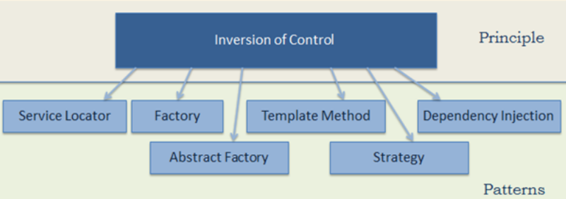
7.3 - Inversion of Control (IoC)
IoC: is a process in which an object defines its dependencies without creating them.
In object-oriented programming, there are several techniques to implement inversion of control:
- using a factory pattern
- using a service locator pattern
- using dependency injection

7.4 - Dependency Injection (DI)
Dependency Injection: a design pattern that removes the dependency from the code.
- We may specify classes' dependencies through annotations or from external source, such as XML file.
- We do not create the objects, but just define how they should be created by the IoC container.
Dependencies can be injected in two ways
- By constructor – The <constructor-arg> subelement of <bean> is used for constructor injection
<constructor-arg value="101" type="int"></constructor-arg>
- By setter method – The <property> subelement of <bean> is used for setter injection
<property name="id" value="101"></property>
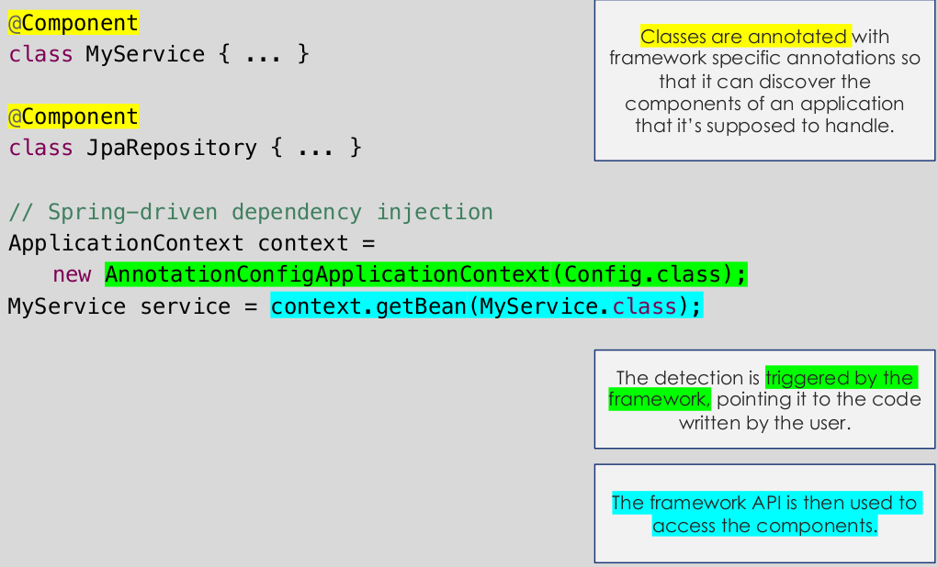

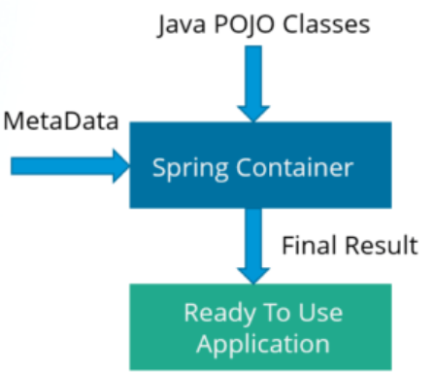
7.5 - Spring IoC Container
Spring IoC is the heart of the Spring Framework.
Each object delegates the job of constructing to an IoC container.
The IoC container receives metadata from either
- an XML file,
- Java annotations, or
- Java code
and produces a fully configured and executable system or application.

The main tasks performed by the IoC container are:
- Instantiating the bean
- Wiring the beans together
- Configuring the beans
- Managing the bean’s entire life-cycle

Two types of Spring IoC containers:
- the BeanFactory provides the configuration framework and basic functionality, and
- the ApplicationContext adds more enterprise-specific functionality.

ApplicationContext
Interface org.springframework.context.ApplicationContext.
- It supports the features supported by Bean Factory but also provides some additional functionalities.
- It follows eager-initialization technique which means instance of beans are created as soon as you create the instance of Application context.

The Spring framework provides several implementations of the ApplicationContext interface
- ClassPathXmlApplicationContext and FileSystemXmlApplicationContext for standalone applications,
- WebApplicationContext for web applications.

7.6 - Beans
"the objects that form the backbone of an application and that are managed by the Spring IoC container are called beans. A bean is instantiated, assembled, and managed by the IoC container."
Spring is responsible for creating bean objects. But first, we need to tell the framework which objects it should create.
- Bean definitions tell Spring which classes the framework should use as beans.
- Bean definitions are like recipes. They also describe the properties of a bean.

Defining Bean Spring:
Three ways:
- annotating a class with the @Component annotation (or its derivatives, @Service, @Repository, @Controller)
- writing a bean factory method annotated with the @Bean annotation in a custom Java configuration class
- declaring a bean definition in an XML configuration file
The choice between bean definition methods is mainly dictated by access to the source code of a class that we want to use as a Spring bean.
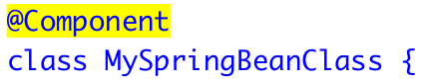
Spring Bean as @Component:
If we own the source code, we'll usually use the Component annotation directly on a class.

- At runtime, Spring finds all classes annotated with @Component or its derivatives and uses them as bean definitions.
- The process of finding annotated classes is called component scanning.
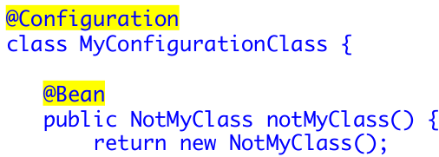
Using @Bean for factory methods:
For classes we don’t own, we have to create factory methods with the @Bean annotation in a custom bean configuration class.
- If we don’t want to make a class dependent on Spring, we can also use this option for classes you own.
The @Configuration annotation also comes from Spring. The annotation marks the class as a container of @Bean definitions.
- We may write multiple factory methods inside a single configuration class.

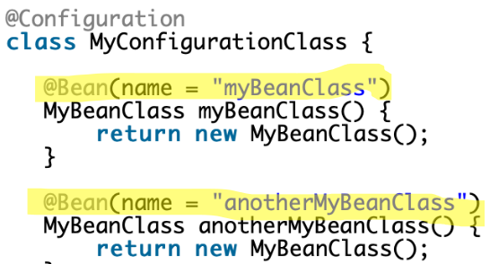
Spring Beans properties
Properties give details about how Spring should create objects.
The list of Spring bean properties includes:
- class
- name - must be unique across the whole application
- dependencies
- scope
- initialization mode
- initialization callback
- destruction callback
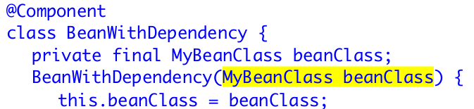
Bean Dependencies:
For a class with only one constructor, marked with @Component Spring uses the list of constructor parameters as a list of mandatory dependencies.
If a bean class defines multiple constructors, one must be marked with @Autowired.
- This way Spring knows which constructor contains the list of bean dependencies.
- Before Spring 4.3, @Autowired annotation was mandatory on every constructors.

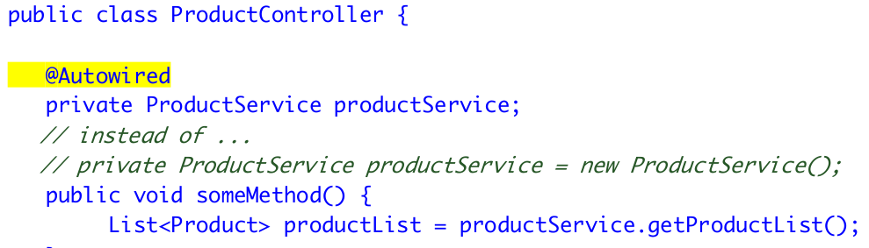
@Autowired annotation:
It is used to wire a bean to another one without instantiating the former one.
- By marking a bean as @Autowired, Spring expects it to be available when constructing the other dependencies.

Some Sprint annotations:
- @ComponentScan: A crucial annotation which specifies which packages contain classes that are annotated. It is always used alongside the @Configuration annotation.
- @Required: is used on setter methods and constructors, to tell Spring that these fields are required to initialize the bean.
- @Scope: is applied on bean-level and defines its visibility/life cycle.
- @Value: It has quite a few use-cases in Spring. More on SpEL..

Spring Expression Language (SpEL)
SpEL can be used for querying and manipulating an object graph at runtime.
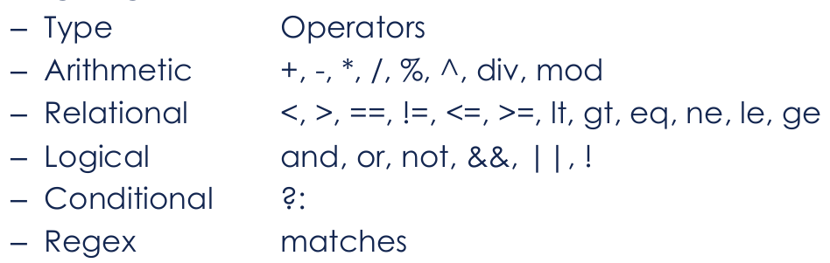
- SpEL is available via XML or annotations and is evaluated during the bean creation time.
There are several operators available in the language ————>

SpEL Examples:
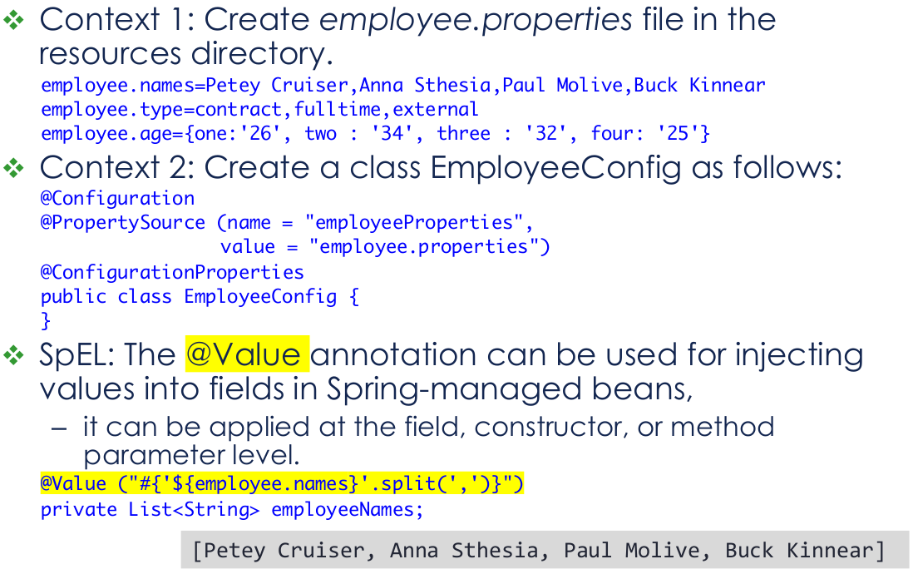

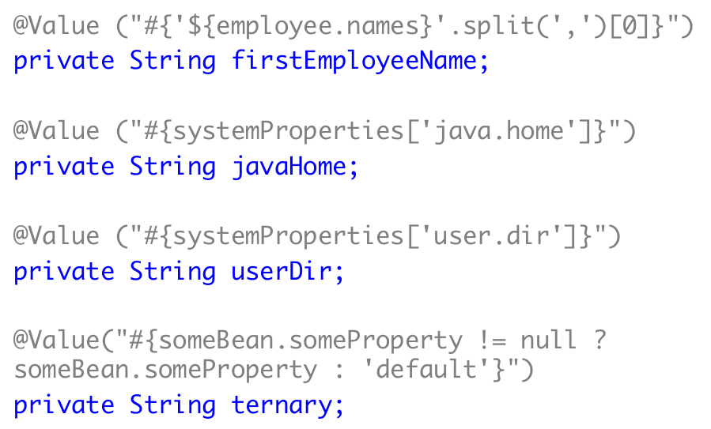

7.7 - Aspect Oriented Programming (AOP)
AOP: a programming approach that allows global properties of a program to determine how it is compiled into an executable program
AOP breaks down the logic of program into distinct parts called concerns. This increases modularity by cross-cutting concerns.
- A cross-cutting concern is a concern that affects the whole application and is centralized in one location in code like transaction management, authentication, logging, security etc.
AOP can be considered as a dynamic decorator design pattern.
- The decorator pattern allows additional behavior to be added to an existing class by wrapping the original class and duplicating its interface and then delegating to the original.

Core AOP Concepts:
- Aspect: a modularization of a concern that cuts across multiple classes (e.g., transaction, logger) is known as the aspect.
  - It can be normal class configured through XML configuration or through regular classes annotated with @Aspect.
- Join point: a point represents a method execution during the execution of a program, such as the execution of a method or the handling of an exception.
- Advice: action taken by an aspect at a particular join point. Different types of advice include "around," "before" and "after" advice.
- Pointcut: a predicate / expressions that are matched at join points to determine whether advice needs to be executed or not.
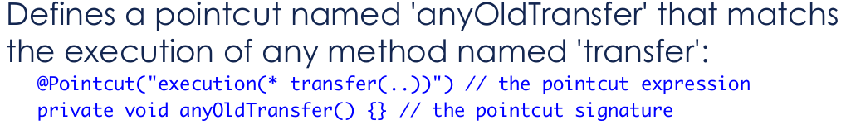
EX:
- @PreAuthorize("hasRole('ADMIN')")
- @Transactional
- @Around("methodsToBeProfiled()") // action taken at the join point.
- @Pointcut("execution(public * foo..*.*(..))")

7.8 - Spring Web
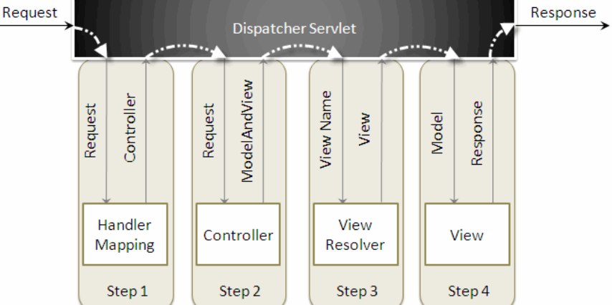
MVC Flow
-> After receiving an HTTP request, DispatcherServlet consults the HandlerMapping to call the appropriate Controller.
-> The Controller takes the request and calls the appropriate service methods based on used GET or POST method.
- The service method will set model data based on defined business logic and returns view name to the DispatcherServlet.
-> The DispatcherServlet will take help from ViewResolver to pickup the defined view for the request.
-> Once view is finalized, The DispatcherServlet passes the model data to the view which is finally rendered on the browser.

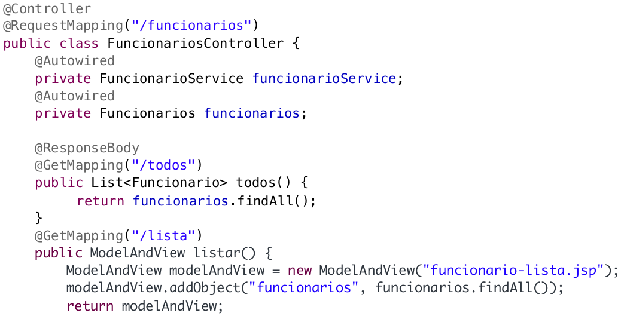

7.9 - Spring Data Access modules
- JDBC: This module provides JDBC abstraction layer which eliminates the need of repetitive and unnecessary exception handling overhead.
- ORM: ORM stands for Object Relational Mapping. This module provides consistency/ portability to our code regardless of data access technologies based on object oriented mapping concept.
- OXM: OXM stands for Object XML Mappers. It is used to convert the objects into XML format and vice versa. The Spring OXM provides an uniform API to access any of these OXM frameworks.
- JMS: JMS stands for Java Messaging Service. This module contains features for producing and consuming messages among various clients.
- Transaction: This module supports programmatic and declarative transaction management for classes that implement special interfaces and for all your POJOs. All the enterprise level transaction implementation concepts can be implemented in Spring by using this module.

